Temperature Gradient-Based DNA Computing for Graph Problems with Weighted Edges
Ji Youn Lee, Soo-Yong Shin, Sirk June Augh,
Tai Hyun Park, Byoung-Tak Zhang
Preliminary Proceedings of the Eighth International Meeting on DNA Based Computers (DNA8), pp. 41-50, 2002.
Abstract
We propose an encoding method for numerical data in DNA using temperature gradient. To represent numerical values in DNA sequences, we introduce melting temperature (Tm). When DNA strands representing smaller values have a lower Tm, they tend to denature with ease and also easily amplified by denaturation temperature gradient PCR. We also implement a local search molecular algorithm. The method is verified by solving an instance of TSP.
- Melting Temperature Control Encoding
- Tm depends on the GC content and thermodynamic factors
- Sequences are generated by the NACST (Nucleic Acid Computing Simulation Tookit) sequence geneator.
- DNA sequence design can be considered as a numerical optimization problem
- NACST/Seq is a sequence design system with multiobjective optimization

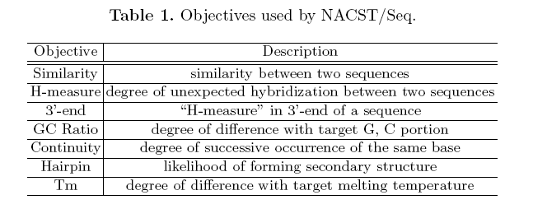
- Algorithm
- Example: TSP
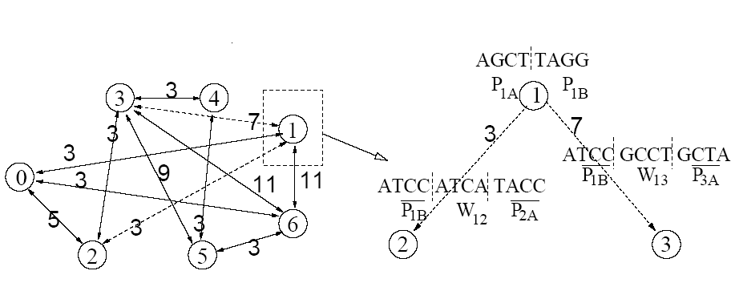
- Encoding of edge:
A B

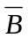 weight 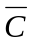
C D DD

- Temperature Gradient Algorithm

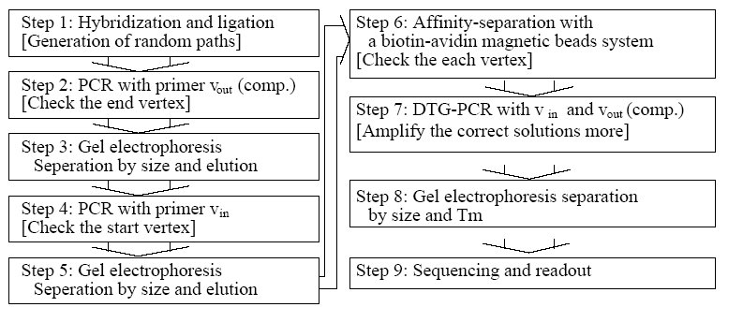
- In Step 1, the concentration gradient is only a tool to generate more possible solutions
- From Step 2 to Step 5 :


5`
3`

5`
3`

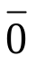

- Affinity Purification :
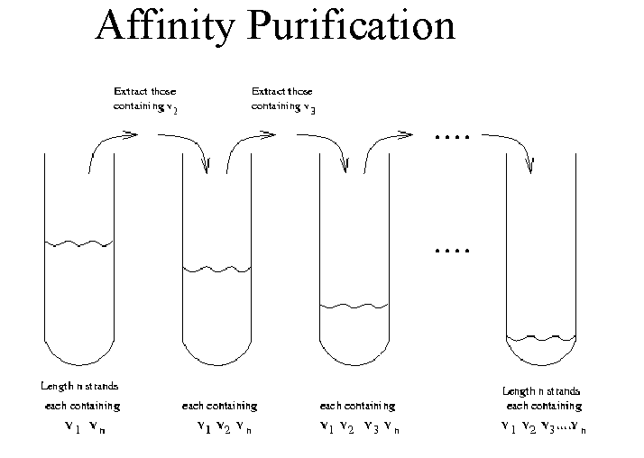

- DTG-PCR : Denaturation Temperature Gradient PCR :
We can specifically amplify the DNA strands with a lower melting temperature by denaturing the dsDNA in the lower temperature in the starting cycles and gradually increasing the denaturation temperature.

Created by : Hung-Wei Huang
Date : Feb. 18, 2004

